Dear Parents and Students,
It is our pleasure to greet and welcome you to our school year 2024-2025. Classes are scheduled to start at ISGL (Islamic Society of Greater Lowell) Masjid starting September 22nd, 2024. We start each year with the vision of achieving excellence in every aspect at Al Rahma Sunday School at ISGL.
As with any school, there are policies, procedures and guidelines that must be followed to ensure a smooth school operation.
We therefore expect your support and cooperation to achieve the goals and objectives of Al Rahma Sunday School and to provide a solid foundation for the future of our children.
POLICIES AND PROCEDURES
OBJECTIVE
Al Rahma main goal is to make the Masjid a central figure in the lives of our Muslim children from a very young age. Al Rahma is also committed to offering its students a solid curriculum of Quran, Arabic and Islamic Studies. Al Rahma will strive to provide the highest education possible to instill Islamic practices and values into each student.
SCHOOL CALENDAR (2024-2025)
9/22/2024 | First Day of School
10/01/2024 | Last Day of Registration
12/01/2024 | November Break
12/22/2024 | Winter Break 1
12/29/2024 | Winter Break 2
01/19/2025 | Midterm Exam
02/16/2025 | February Break
03/23/2025 | Ramadan Last 10 Break
03/30/2025 | Eid Al-Fitr Break
04/20/2025 | April Break
05/18/2025 | Final Exam
06/01/2025 | Ceremony Day / Last Day of School
Note: The school will stay committed to this calendar so that parents and students can plan their year accordingly. In rare circumstances, the schedule may change due to unforeseen events, in which case parents will be notified immediately. If school is canceled due to inclement weather or any other reason, Al Rahma School will send a notification email to parents to inform them of the date and the reason for cancelation.
REGISTRATION
The school offers a good curriculum of Islamic Studies and Quran/Arabic through 9 progressive grades (Grade 9 being the latest addition), after which the students will join a 3-year rotation youth program with a new minimum age rule of at least 15.
Registration this year will be open from 05/10/2024 to 10/01/2024, that’s almost a five-month registration window. We highly encourage parents to enroll their children early so they will not miss out on early classes during the year. By 10/01/2024 at midnight, registration will have closed and parents will not be allowed to register their kids except if the said parents just recently moved to the area from a faraway town/city/state.
The school will make every effort to broadcast the opening of the registration campaign and communicate the registration link through all means available at the time (school email list, ISGL Whatsapp group, website, social media, …). The online registration form asks for student general information and parent contact information. The form must be filled out by parents and all fields should be double checked to avoid mistakes in spellings. During the first 2-3 weeks of school, there will be dedicated school staff at the front desk who will help with in-person registration, just walk in and ask for help to register your children if you have not done so using the online registration form.
Please make sure your contact information is correct and up to date especially the phone numbers and emails section because that would be our only way to get in contact with you regarding school matters. Also, please make sure to fill out the known allergies section accurately so that we ensure your kids are never presented with food they could be allergic to.
We only accept students with ages between 5 and 18. For younger students, they must be at least 5 years old by December 31st 2024 to be admitted, there will be no exceptions. Students older than 18 on first day of school are considered too old for the activities offered by the school and will not be eligible to enroll in the youth program. Please do not register your kids if they do not meet the criteria described above.
After the registration period ends, parents will be invited to join WhatsApp grade groups where their kids are enrolled. These groups allow teachers, parents and administration to stay close and communicate efficiently about all school matters and events.
TUITION
All parents will be asked to pay tuition for the year on the first day of school or come to an agreement with the administration about an interest-free installment plan where payments are made at the beginning of each month starting October 1st. Accepted methods of payments are cash, check and debit/credit card. Tuition covers school expenses related to operations, purchase of books/supplies/materials, organizing events for students, etc... The school is committed to offer high quality services while maintaining low cost of operations so that tuition is affordable by majority of parents. Annual tuition for this school year is as follows:

Grades 1 – 9: $350 per child + $200 per additional child
Youth: $180

Examples:

 | Example 1 | Example 2 | Example 3
# kids in Grades 1-9 | 1 | 2 | 3
# kids in Youth | 0 | 0 | 1
Total Tuition | $350 | $350 + $200 = $550 | $350 + 2x$200 + $180 = $930

SCHOOL HOURS
On regular days, Al Rahma School starts at 10:00 AM and finishes at 1:00 PM every Sunday (except Sundays off noted in the calendar). There are two main sessions; the first session from 10:00 AM to 11:30 AM is dedicated to Islamic Studies while the second session from 12:00 PM to 1:00 PM is dedicated to Quran/Arabic. Students get 30 min recess to socialize, play and eat snacks. It is highly recommended that parents provide their children with snacks. In case some students forget theirs, the school may occasionally provide snacks for them when available.
The ISGL lower-level space is entirely reserved for school operations on Sundays between 8:00 AM to 1:00 PM. For safety and logistical reasons, no one is allowed to be in school premises between 10:00 AM to 1:00 PM except for students and staff. Parents are allowed to come in to drop off their kids and leave right after. Parents who wish to speak with a school admin or teacher can do so before school starts (before 10:00 AM) or after school is finished (after 1:00 PM).
In Ramadan, Al Rahma School starts at 11:00 AM and finishes at 1:00 PM. First session will be an hour long instead of 90 minutes while the second session will last 45 minutes with a 15 minutes break in between. In observance of the last 10 nights of Ramadan leading to Eid Al-Fitr, there will be no school on the 23rd and 30th of March (see calendar).
ATTENDANCE
Students are expected to attend all classes each Sunday. Each absence interferes with your child’s ability to benefit from his/her class. In case of absence, parents are asked to inform the school administration ahead of Sunday session through call, text (regular & WhatsApp) or email to explain the reason for the absence. Failure to comply has the following progressive consequences:
- If unnotified, teachers will ask students for the reason for their absence when they meet up the following Sunday. Any assignments missed should be made up by students within the time frame given by the teacher.
- Two consecutive absences or two absences in any three-week streak without prior notice will trigger a phone call and email from the administration to follow up with parents.
- Three consecutive absences or three absences in any four-week streak without prior notice will trigger a final warning call, text and email.
- Four consecutive absences or four absences in any five-week streak without prior notice will result in student dismissal from the school.
This is how you justify an absence/late arrival:

When? Contact us before classes start on Sunday, preferably at least 24 hours before

How? Notify us by one of these 4 methods:
- Send an email to alrahma.isgl@gmail.com
- Call 978-364-0219. Leave a voicemail if no one picks up.
- Text 978-364-0219
- Leave a WhatsApp message in your student grade group

What? We need to know:
- Student full name (first name + last name)
- Student grade
- Date and duration of absence/late
- Reason for absence/late

Like the previous year, absence (justified or unjustified) will account for 20% of overall student grade except for long term leave with prior notification to administration. One sick day per semester is typically granted to all students and will not be counted toward the final grade. This policy has been put in place to keep all parties honest. Being absent means missing out on important learning opportunities, that’s why ALL absences will be marked and used toward the 20% target of overall grade.
Not showing up for events organized by the school also counts as absence like any other regular session. Missing out on exams, school projects/assignments purposefully and without a valid reason will result in a grade of 0 for that particular item. No make up exam will be scheduled in that case.
School hours are 10:00 AM to 1:00 PM. Half-day attendance is not allowed: a child will not be allowed to only attend one of the sessions and be excused from the other without a valid excuse.
ILLNESS
Out of consideration for other children, parents are requested to keep their sick child at home until he/she feels better. Children will need one fever free day before coming to school. Due to the flu season every fall/winter, we urge all parents to keep their children at home, if they have flu-like symptoms.
TARDY
Excessive tardiness interferes with the student’s ability to benefit from class. Also, it disrupts the flow of the lesson and causes distraction for students and teachers. Students are expected to arrive on time and be prepared to start class at 10:00 AM each Sunday.
In continuation of our 0-tolerance policy toward tardiness, the following measures will be adopted:
- If a student arrives after 10:00 AM (previously was 10:05 AM), he/she will not be allowed in class unless he/she gets a tardy slip from the administration which he/she will hand to the teacher before entering the classroom.
- School doors will be locked after 10:10 AM (previously was 10:20 AM), parents dropping their kids after that time will be asked to take them back home unless we receive a written message (email, text, WhatsApp) before 10:10 AM letting us know about the late arrival. If the student is asked to leave, this will count as one absence on the student record.
- A student will typically be forgiven for four late showings (arriving between 10:00 AM and 10:10 AM) per school year. Any subsequent late showings (five and up) will result in the student being sent home and marked as absent.
DROP-OFF
Parents must plan to bring their children on time so that they are not penalized for late showings, they should typically plan to arrive 5 to 10 minutes before classes start. For extra security, there will be assigned school staff members every Sunday morning from 9:45 AM to 10:00 AM to enforce parking safety protocols. Parents are also kindly reminded to be mindful of other drivers behind them who are waiting to drop off their children. Upon arrival, get in the line queue and stay in your car until you reach the front of the Masjid. When it is your turn, and only when instructed by one of our volunteers, you can then drop off your kids, then please leave immediately when it is safe. No need to park or get out of your car. Some cars have safety features requiring someone from outside to open the door, our volunteers will do that for you. If you insist on coming with your children inside, then the back of the Masjid will be reserved for that reason. If you choose this option, then you need to park in the back and escort your children inside.
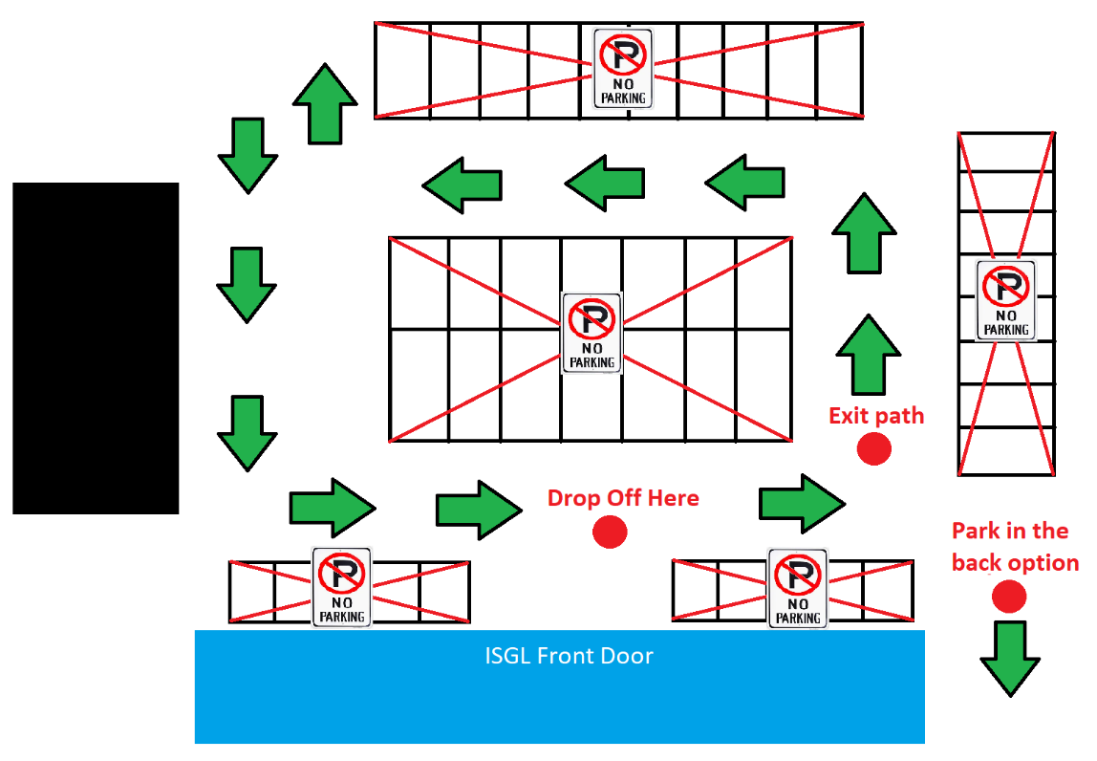
Our volunteers will show you where you can safely park without hindering the flow of other cars. No one is allowed to park in any parking spot facing the Masjid, all of those are reserved for staff members only. Everyone MUST follow instructions of our volunteers in the parking lot. It is very dangerous when parents get impatient and try to go from the sides or drop off their kids when it is not their turn yet.
Failure to follow the aforementioned guidelines purposefully, or arguing/getting aggressive with one of the volunteers will be dealt with swiftly. Zero tolerance for staff members getting disrespected or yelled at!
PICK-UP & EARLY RELEASE
School ends at 1:00 PM. For safety reasons, students are allowed to leave the school only if a parent comes inside and picks them up for all grades (Grade 1 - Youth), no exceptions. Youth who have their own car/walk to home will need to tell one of the staff before leaving. The school encourages parents and students to stay until 1:15 PM to pray Duhr in congregation in the Masjid which usually takes about 5 to 10 minutes.
In general, early pick-up is a practice the school discourages, but if a child needs to leave early, the parent is required to email the school in advance and state the student’s full name, the reason for early release and the pick-up date/time. The parent picking up the child needs also to sign the “Early Release Form” found at the front desk.
EXAMS, GRADING & PASS/FAIL
In coordination with all teachers, the school organizes two official exams throughout the year that count toward pass/fail criteria for the following year:
- Midterm/Winter Exam after about 13 weeks of active sessions. This marks the end of the first semester
- Final/Spring Exam after about 13 weeks of active sessions that follow the midterm. This marks the end of the second semester
For this current school year, please refer to the calendar on the first page for exact exam dates. A report card will be shared with you after each semester.
Midterm and final exams are each scored out of a 100. They have an “Islamic Studies” and “Quran” portion, teachers decide the weight of each portion. On the Islamic Studies portion, questions will be diversified in style, innovative and thought-provoking that challenge students' critical thinking skills. On the Quran portion, students will be tested on memorization and meaning/understanding of the verses.
Students must have a valid reason for not showing up to these two major exams like sickness, travel or emergency. School will work with said students on a make-up exam the following school day. Make-up exams will not be provided for students who are absent for no valid reason, a reason will be deemed valid or invalid at the discretion of the administration.
There will be projects and assignments given to students throughout the year. It is very important for parents to follow up with their kids to make sure that projects and assignments are completed promptly. There can be times where teachers decide to have a test/quiz in class generally limited in scope to keep students engaged with class material throughout the year. Projects, Tests, Assignments and Participation (referred in this document as PTAP) accounts for 20% of final grade.
Attendance for this year will account for 20% of overall grade, ALL absences will be counted except for one sick day per semester.
Final Grade Distribution:
- Attendance: 20%
- Projects, Tests, Assignments and Participation (PTAP): 20%
- Midterm: 30%
- Final: 30%

Final grade is the main criterion to determine students passing to next grades for the following school year. The objective criteria that the school will use is as follows:
Final Grade >= 60: Automatic Pass
50 <= Final Grade < 60: Up for Debate
Final Grade < 50: Fail
At the request of parents, last resort make-up exams can be made available for failing students at the beginning of the following school year to assess if they made an effort during summer to study and rectify the poor showing during the previous year. If the result is satisfactory (at the discretion of the teacher and administration), then the said students will be allowed to progress to the next grade, otherwise they will have to repeat the class. Passing or failing a grade is a matter discussed internally between teachers and the principal. Final decision will be made at the discretion of the school. All decisions are final.
EVENTS
The school will typically try to organize two fun events for students throughout the year to make the Islamic learning experience much more appealing. In previous years for example, the school organized a World Cup Final event indoors where all students got together and watched the game, food and snacks were provided. Also, an Islamic quiz competition was organized to assess students’ levels and top contenders received cash prizes. School also organized outdoor Laser Tag events which were well received by parents and were entertaining for students and staff. Event related information will always be communicated to parents ahead of time for better planning.
PARENT-SCHOOL COMMUNICATION
Please feel free to communicate any suggestions/concerns you may have about the school, your child, teacher, or staff. We welcome your feedback to let us know how we are doing. See “Contact Information” section below for ways to contact us.
For phone calls, we will pick up the phone on Sundays from 9:30 AM to 1:00 PM. Also, you can contact the school anytime and leave a voicemail/text message. A staff member from the communications department will respond to you within 48 hours.
STUDENT CODE OF CONDUCT
1. Respect and Dignity
- Respect for Others: All students are expected to treat their peers, teachers, and staff with respect, kindness, and consideration. This includes refraining from any form of bullying, harassment, or discrimination.
- Respect for Property: Students must respect school property, personal belongings of others, and the environment.

2. Adherence to Islamic Values
- Modesty in Dress: Students must adhere to the school’s dress code, which reflects Islamic principles of modesty. Short pants are not allowed. All girls should wear head scarves/Hijab.
- Honesty and Integrity: Cheating, lying, or stealing is strictly prohibited.
- Behavior and Language: Students are expected to use appropriate language and exhibit behavior that reflects Islamic teachings, avoiding foul language, gossip, and backbiting.

3. Attendance and Punctuality
- Regular Attendance: Students must attend school regularly and arrive on time.
- Punctuality in Submissions: Homework and assignments must be completed and submitted on time.

4. Engagement and Effort
- Participation: Students are encouraged to actively participate in classes and school activities.
- Effort in Academics: All students should strive to achieve their best in all academic and extracurricular endeavors.

5. Safety and Well-being
- Safe Environment: Students must refrain from actions that endanger themselves or others.
- Prohibition of Harmful Substances: The possession or use of harmful substances, such as tobacco, drugs, or alcohol, is strictly forbidden.

PROGRESSIVE DISCIPLINE ACTIONS
1. Minor Infractions
Examples: Tardiness, incomplete homework, minor disruptions in class.
Actions:
- Verbal Warning: Teacher addresses the issue directly with the student.
- Written Warning: A note is sent home, and parents are informed.
- Loss of Privileges: Temporary loss of privileges, such as recess or extracurricular activities.

2. Moderate Infractions
Examples: Repeated minor infractions, disrespectful behavior, dress code violations, unauthorized use of telephones or other electronic devices during class.
Actions:
- Confiscation: The teacher may confiscate the phone or device for the remainder of the day.
- Parent-Teacher Conference: A meeting is arranged to discuss the student’s behavior and possible solutions.
- Behavioral Contract: The student may be placed on a behavioral contract outlining expected behavior and consequences for further infractions.
- Detention: The student may be required to stay after school or during recess to complete missed work or reflect on their behavior.

3. Serious Infractions
Examples: Bullying, cheating, theft, physical aggression, or any behavior that compromises the safety of others.
Actions:
- In-School Suspension: The student is removed from regular classes but remains in school.
- Out-of-School Suspension: Temporary suspension from school, requiring a meeting with parents before the student is allowed to return.
- Counseling: Mandatory counseling sessions to address underlying issues.

4. Extreme Infractions
Examples: Possession of weapons, illegal substances, severe physical violence.
Actions:
- Long-Term Suspension: Extended suspension, possibly leading to expulsion depending on the severity of the infraction.
- Expulsion: Permanent removal from the school. This is considered a last resort and is only implemented after a thorough review by the school administration.

STUDENTS & PARENTS RESPONSIBILITIES
Students:
- Attend class regularly.
- Have appropriate materials for class.
- Arrive at school prepared to learn.
- Recognize and respect the rights of classmates.
- Respect teachers at all times.
- Respect the Masjid and its facilities.
- Comply with and conform to all class/school rules.
Parents:
- Be aware of and understand school policies.
- Help promote a positive attitude.
- Help students in regard to attendance and studying.
- Communicate with teachers.
- Communicate any concerns to the administration.
- Report any changes in email and phone to school staff.
CONTACT INFORMATION
Email: alrahma.isgl@gmail.com
Call/Text: 978-364-0219

